CPFT Library Services
Library services and resources are available to all staff and students on placement.
There are two library sites – Victoria House (main library) and Cavell Centre (satellite library), which are staffed by two trained librarians.

Books
- Online book catalogue (see web pages for details & access)
- 2500 print books available
- Borrow up-to 6 Books for 6 months
- 5 Renewals in total
- NO FINES!

Journals
- Approx. 4000 e-journal subscriptions
- 30 print journal subscriptions
- Articles sent as PDF to your email

Inter-library Loans (ILL)
- Ability to access books or journal articles from other libraries across the country, including British Library

Document Supply Service

What you can expect - response & delivery times
- Acknowledgement for any request (article or book) within 24 hrs
- 48 hrs delivery for any CPFT article
- 5 days delivery for any ILL
- 7 – 10 days delivery for British Library
- 2 -10 days for any book(s) inc ILL

OpenAthens

- To access e-resources, you will need an OpenAthens account. Sign-up at openathens.nice.org.uk

Other Services

- Literature Search service (Staff only)

- Information Literacy training

- Evidence bulletins to your inbox (KnowledgeShare)
- Journal Alerts: table-of-contents

- Monthly E-Newsletter

Registration Form

Title

First Name Last Name Gender
Job Title Work address

Email Mobile Phone Work Phone Home Phone

Would you like to request and renew books online? If so, please give a 4 digit PIN

Borrower Agreement
Contact Us
I agree to be financially responsible for damages or loss of materials borrowed by this account.
I will not remove reference materials (journals and reference books) from the library without the permission of the librarian, nor disseminate copyrighted library resources without the permission of the copyright holder.
I understand that the library will keep my personal details confidential as far as this is possible under UK law.
I understand that my name, address, telephone number, date of birth and other supplied information will not be used by anyone except the library for official library business.
I agree to abide by the Library rules and regulations and agree that the personal data above and records of my library use may be shared with library staff in accordance with the Data Protection Act 1998. I understand that my information may be accessible to library staff at other NHS and partner organisations within the shared library management consortium to enable loans of other libraries' materials. I understand that my data will not be shared with any third party.
I understand that by signing this form I am agreeing to be bound by the requirements, terms, and conditions contained within.

Signed:
Date:

Please scan and return this form to fulbourn.library@cpft.nhs.uk
Library staff are happy to help with all types of enquiries. Feel free to contact us by phone, email, in-person or via social media channels.
Fulbourn Library (Main Library)

2-4 Victoria House Capital Park Fulbourn
Cams CB21 5XB
Tel: 01223 868 815
Email: fulbourn.library@cpft.nhs.uk
Twitter: @CPFTLibrary
Yammer group: The Library

Library Services
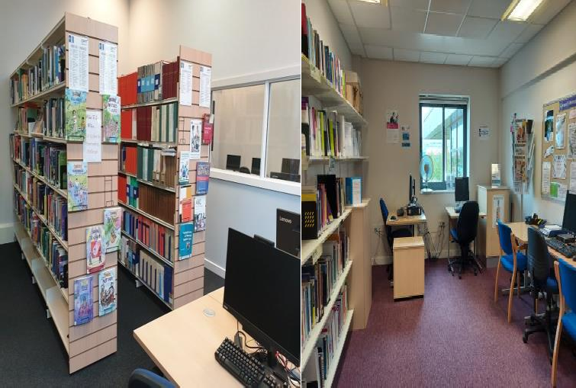
Victoria House & Cavell Centre

Visit the web pages for more information, to access the online book catalogue or use our online request forms to request a service, article or book.

Web site: learning.cpft.nhs.uk/libraries
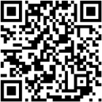

Updated August 2020

