# CPFT Library Services

Library services and resources are available to all staff and students on placement.

There are two library sites – Elizabeth House and Cavell Centre, which are staffed by two trained librarians.

## Books

* Online book catalogue (see Academy/Libraries)
* 2500 print books available
* Borrow up-to 8 Books
* 3 x auto renewals
* NO FINES!

## Journals

* Approx. 4000 e-journal subscriptions
* Articles sent as PDF to your email

## Inter-library Loans (ILL)

* Ability to access books or journal articles from partner libraries.

## Document Supply Service

### What you can expect - response & delivery times

* Acknowledgement for any request (article or book) within 24 hrs
* 48 hrs delivery for any CPFT article
* 5 days delivery for any ILL
* 2 -10 days for any book(s) inc ILL

## OpenAthens

* To access e-resources, you will need an **OpenAthens** account. Sign-up at [openathens.nice.org.uk](https://openathens.nice.org.uk/)

## Other Services

* Literature Search Service (Staff only)
* KnowledgeShare (Evidence alerts to your inbox)
* Journal Alerts (table-of-contents to your inbox)
* Monthly E-Newsletter (Sway)

### Registration Form

**Title**

**First Name Last Name Gender**

**Job Title Work address**

**Email Mobile Phone Work Phone Home Phone**

**KnowledgeShare** is an evidence bulletin personalized to you. Would you like to join? (please circle)

Yes No

**Borrower Agreement**

**Contact Us**

**I agree to be financially responsible for damages or loss of materials borrowed by this account.**

I will not remove reference materials (journals and reference books) from the library without the permission of the librarian, nor disseminate copyrighted library resources without the permission of the copyright holder.

I understand that the library will keep my personal details confidential as far as this is possible under UK law.

I understand that my name, address, telephone number, date of birth and other supplied information will not be used by anyone except the library for official library business.

I agree to abide by the Library rules and regulations and agree that the personal data above and records of my library use may be shared with library staff in accordance with the Data Protection Act 1998. I understand that my information may be accessible to library staff at other NHS and partner organization’s within the shared library management consortium to enable loans of other libraries' materials. I understand that my data will not be shared with any third party.

I understand that by signing this form I am agreeing to be bound by the requirements, terms, and conditions contained within.

Signed:

Date:

**Please scan and return this form to** [**fulbourn.library@cpft.nhs.uk**](mailto:fulbourn.library@cpft.nhs.uk)

Library staff are happy to help with all types of enquiries. Feel free to contact us by email, Teams or in-person.

**Fulbourn Library (Main Library)**

Elizabeth House, Fulbourn Hospital

Cambridge

CB21 5EF

**Email:** [fulbourn.library@cpft.nhs.uk](mailto:fulbourn.library@cpft.nhs.uk)

**Engage group:** CPFT Libraries





**Library Services**

Elizabeth House & Cavell Centre

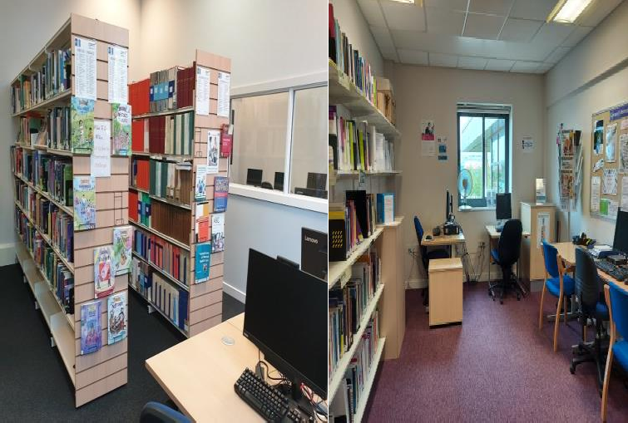

Visit the **web pages** for more information, to access the **online book catalogue** or use our **online request forms** to request a service, article or book.

**Web site:** Academy/Libraries

**Scan QR code:**

